MATLAB Homework #2

**Sean Hwang**

00280-85752

ECE 538

Digital Signal Processing I

Fall 2020



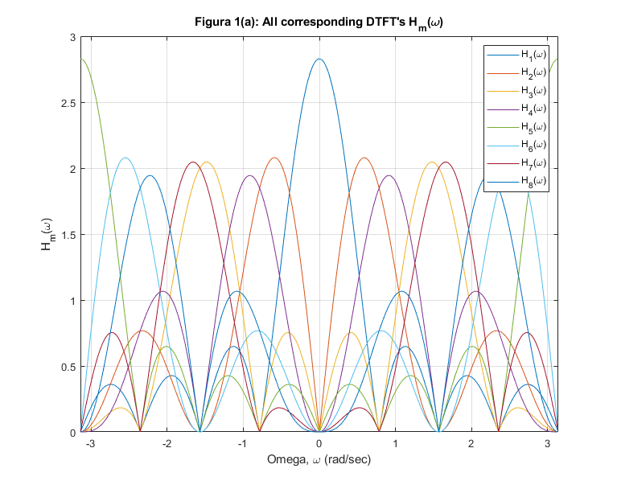

**Figure 1(a):** All corresponding DTFT’s Hm(ω)

|  |  |  |  |  |  |  |  |
| --- | --- | --- | --- | --- | --- | --- | --- |
| 1 | 0 | 0 | 0 | 0 | 0 | 0 | 0 |
| 0 | 1 | 0 | 0 | 0 | 0 | 0 | 0 |
| 0 | 0 | 1 | 0 | 0 | 0 | 0 | 0 |
| 0 | 0 | 0 | 1 | 0 | 0 | 0 | 0 |
| 0 | 0 | 0 | 0 | 1 | 0 | 0 | 0 |
| 0 | 0 | 0 | 0 | 0 | 1 | 0 | 0 |
| 0 | 0 | 0 | 0 | 0 | 0 | 1 | 0 |
| 0 | 0 | 0 | 0 | 0 | 0 | 0 | 1 |

**Table 1:** 8x8 matrix of HHH

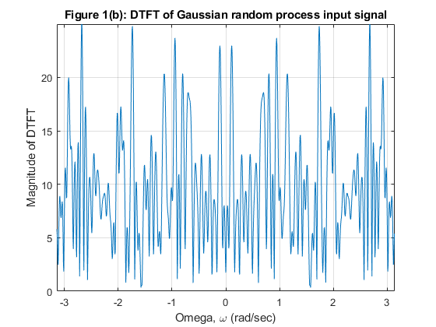

**Figure 1(b):** DTFT of Gaussian random process input signal

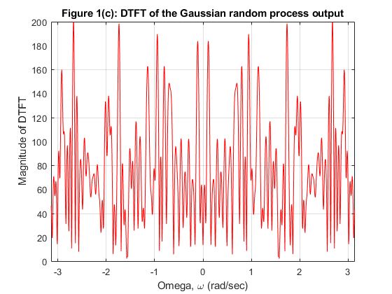

**Figure 1(c):** DTFT of the Gaussian random process output

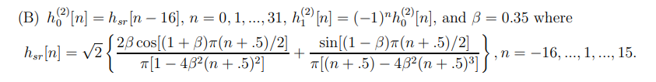

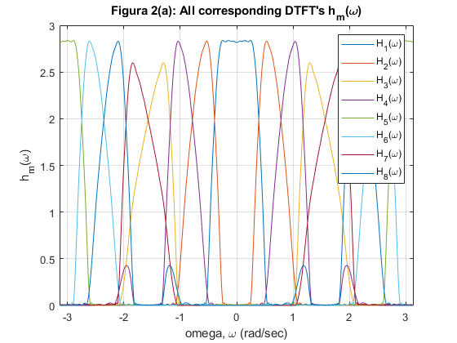

**Figure 2(a):** All corresponding DTFT’s Hm(ω)

|  |  |  |  |  |  |  |  |
| --- | --- | --- | --- | --- | --- | --- | --- |
| 1.000002 | -4.77E-17 | -2.13E-17 | 7.03E-07 | 2.15E-16 | 3.47E-17 | -8.43E-17 | -1.79E-17 |
| -4.77E-17 | 0.999864 | -7.03E-07 | 1.11E-16 | 3.47E-17 | 6.27E-17 | -3.93E-17 | -5.70E-17 |
| -2.13E-17 | -7.03E-07 | 1.000164 | 9.79E-18 | -8.43E-17 | -3.93E-17 | 2.03E-16 | -1.21E-17 |
| 7.03E-07 | 1.11E-16 | 9.79E-18 | 0.999511 | -1.79E-17 | -5.70E-17 | -1.21E-17 | -4.44E-17 |
| 2.15E-16 | 3.47E-17 | -8.43E-17 | -1.79E-17 | 1.000002 | -4.77E-17 | -2.13E-17 | 7.03E-07 |
| 3.47E-17 | 6.27E-17 | -3.93E-17 | -5.70E-17 | -4.77E-17 | 0.999864 | -7.03E-07 | 1.11E-16 |
| -8.43E-17 | -3.93E-17 | 2.03E-16 | -1.21E-17 | -2.13E-17 | -7.03E-07 | 1.000164 | 9.79E-18 |
| -1.79E-17 | -5.70E-17 | -1.21E-17 | -4.44E-17 | 7.03E-07 | 1.11E-16 | 9.79E-18 | 0.999511 |

**Table 2:** 8x8 matrix of HHH for B

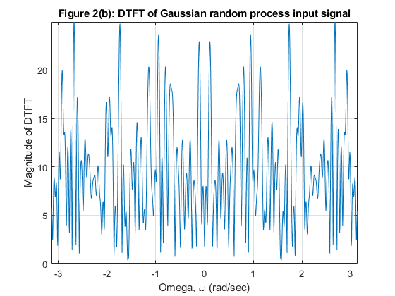

**Figure 2(b):** DTFT of Gaussian random process input signal

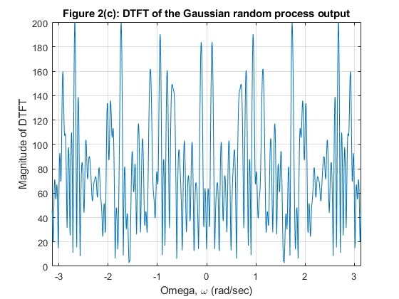

**Figure 2(c):** DTFT of the Gaussian random process output

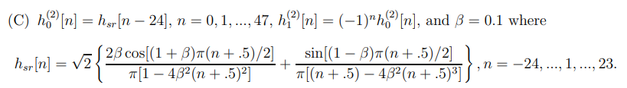

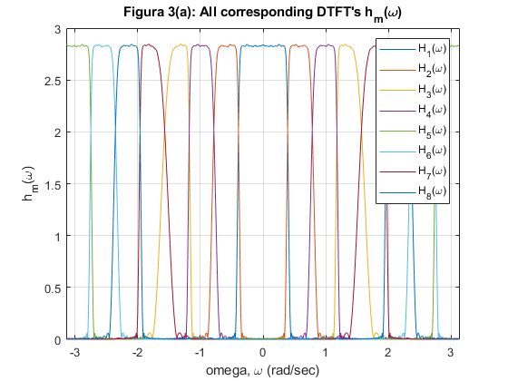

**Figure 3(a):** All corresponding DTFT’s Hm(ω)

|  |  |  |  |  |  |  |  |
| --- | --- | --- | --- | --- | --- | --- | --- |
| 0.999892 | -2.50E-16 | 2.91E-16 | 3.64E-07 | -4.86E-17 | 6.94E-18 | 2.78E-17 | -8.67E-17 |
| -2.50E-16 | 0.999822 | -3.64E-07 | 1.67E-16 | 6.94E-18 | -3.89E-16 | 6.94E-18 | 6.94E-17 |
| 2.91E-16 | -3.64E-07 | 0.999833 | 2.78E-17 | 5.55E-17 | -4.16E-17 | 1.11E-16 | 5.55E-17 |
| 3.64E-07 | 1.67E-16 | 2.78E-17 | 0.999095 | -8.67E-17 | 6.94E-17 | 4.16E-17 | 6.07E-17 |
| -4.86E-17 | 6.94E-18 | 5.55E-17 | -8.67E-17 | 0.999892 | -2.50E-16 | 2.91E-16 | 3.64E-07 |
| 6.94E-18 | -3.89E-16 | -4.16E-17 | 6.94E-17 | -2.50E-16 | 0.999822 | -3.64E-07 | -5.55E-17 |
| 2.78E-17 | 6.94E-18 | 1.11E-16 | 4.16E-17 | 2.91E-16 | -3.64E-07 | 0.999833 | -8.33E-17 |
| -8.67E-17 | 6.94E-17 | 5.55E-17 | 6.07E-17 | 3.64E-07 | -5.55E-17 | -8.33E-17 | 0.999095 |

**Table 2:** 8x8 matrix of HHH for C

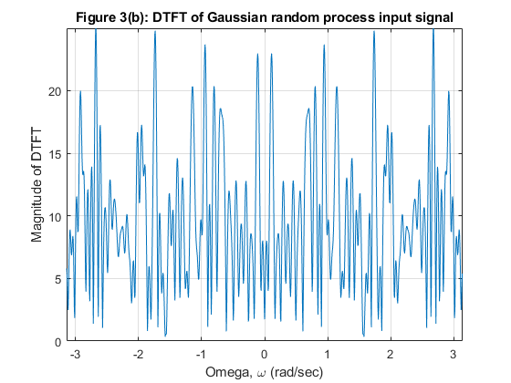

**Figure 3(b):** DTFT of Gaussian random process input signal

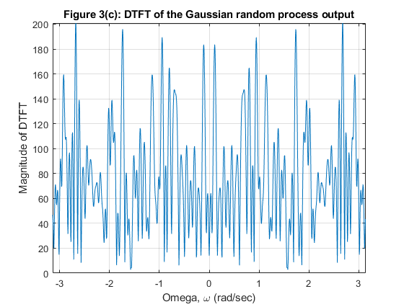

**Figure 3(c):** DTFT of the Gaussian random process output

**Observations and conclusion from the experiment:**

The computer experiment was conducted successfully, and a M=8 channel perfect reconstruction filter bank was synthesized from a three stage three-structured PR filter bank. The biggest, and most obvious observation that I was able to make from this experiment was that the DTFT magnitude from the output of filter was 8 times greater than the gaussian random process signal that was inputted to the filter. This is a definitive proof that the three stage tree-structured PR filter bank was successfully synthesized to an M=8 channel uniform PR filter bank according to Noble’s Identity. The plot of DTFT of the input signal and the output have an identical shape, but the two plots only differ in the magnitude of signal with output amplified to the factor of 8.